# GUI - Overview

On launching the application, the GUI window as shown in Figure 11 will come into view.

**Note**: In case of windows display setting Scale and layout is more than 125%, GUI window might go out of screen.

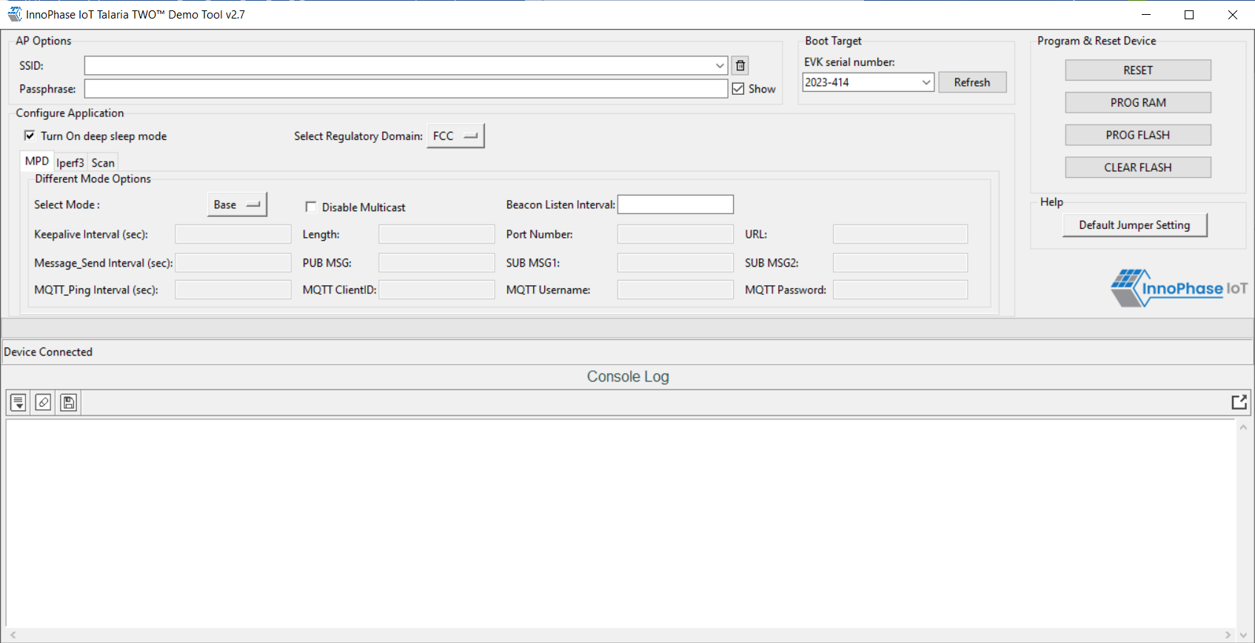

Figure 11: Demo Tool GUI

1. **Boot Target**: Connected EVKs appear in the EVK serial number drop-down and the appropriate EVK can be selected.

**Note**:

If any connected EVK devices do not have a serial number, the Download tool will automatically handle this by generating a new serial number and update the same onto the corresponding device. During this process, the tool will indicate this in the status bar, as shown in Figure 12.

Format of the new serial number:

|  |
| --- |
| <year_stamp>-<integer> |

where,

- <year_stamp>: Current year. For example: 2023

- <integer>: Formed from the sum of last 3 octets (in decimal) of the MAC address found in the device.

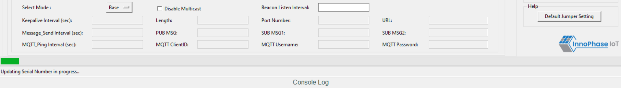

Figure 12: Boot target – Serial number update

Since a new serial number is generated from the MAC address of the device, devices with the same MAC address will get updated with the same serial number. This is an expected behavior.

User can manually update the new serial number to the device following the instructions mentioned in section: New Serial Number to Device – Manual Method.

1. **AP Options**: The SSID and Passphrase entered in the respective fields will connect the EVK board to the Access Point. Once connected, as per requirement MPD/iPerf3/Scan applications can be loaded by selecting the appropriate tab.
2. **Configure the Application**: Configure the Setup Parameters:
   1. **Turn On deep sleep mode**: When the processor is idle or is waiting for an event or data to occur or be received, turning ON the Turn On deep sleep mode feature by checking the box adjacent to the field will put Talaria TWO in a power saving mode.
   2. **Select Regulatory Domain**: Depending on their region of operation, the user can select any one of the following appropriate regulatory domains to establish a connection between the EVK board and the Access Point:
      1. FCC
      2. ETSI
      3. TELEC
      4. KCC
3. **Program and Reset the Device**:
   1. **RESET**:

Reload the application in Flash memory

* 1. **PROG RAM**:

Program the application to RAM memory

* 1. **PROG FLASH**:

Program the application to Flash memory

* 1. **CLEAR FLASH**:

Erase the application in Flash memory

**Note**:

PROG RAM will clear the application from Flash. The user is alerted of the same during PROG RAM through a pop-up message as shown in Figure 13. User can select the Do not show again checkbox to stop this pop-up message from appearing next time.

Figure 13: PROG RAM alert message

The console window is as shown in Figure *14*.

Figure 14: Console window

The console window has the following icons (with Hover Text):

1. **Auto Scroll** A black and white sign with a down arrow

   Description automatically generated: Enables scrolling of console content till the end (default mode).
2. **Pause Scroll** A grey square with a black arrow

   Description automatically generated: Turns OFF Auto Scroll mode.
3. **Clear Console** : Clears console window content.
4. **Save Logs** : Opens a file dialog with Console_Output.log as the default file name to save the logs.

Note: Only upcoming data after starting the Save Logs is saved in the file.

1. **Stop Save Logs**  : Stops saving console logs to the file. This icon appears after Save Logs is started successfully.
2. **Pop Out** : Pops out the console window separate from the GUI window.
3. **Pop In** A black and white image of a square and a square with an arrow pointing up

   Description automatically generated: Embeds the console and GUI window together.

Keeping this tool idle for a while (around 2 to 3 hours), may lead to loss of communication to the EVK device. This is indicated in the console as “Error communicating with FTDI device”, as show in Figure 15. Workaround for this is as follows:

1. Close the tool
2. Unplug & re-plug the EVK
3. Re-open the tool again

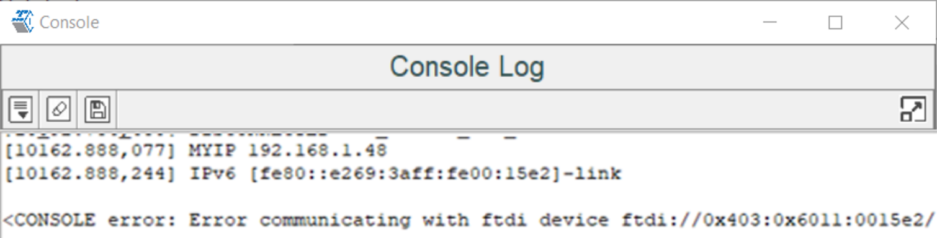

Figure 15: Error communicating with FTDI device